**TASK 1: GITHUB COMMITS**

**TEAM 1**

**User 1:Josalin A J**

* Cloned the repo to local machine
* Created a new file - “team1.txt”
* Added 2 functions in it -

{

A() {}

B() {}

}

* Pushed it to main branch of the repo by adding and committing

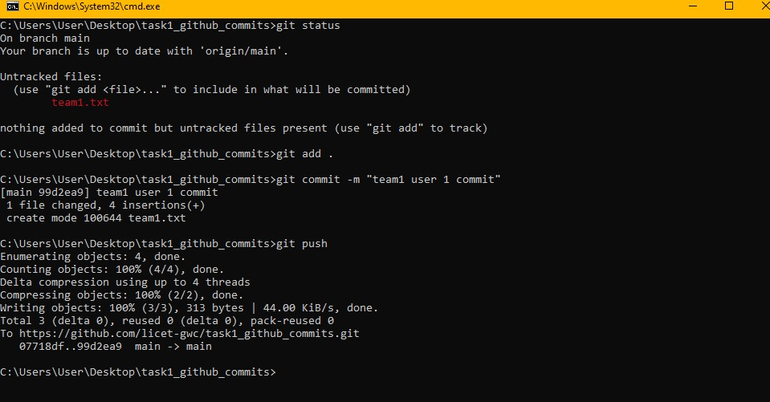

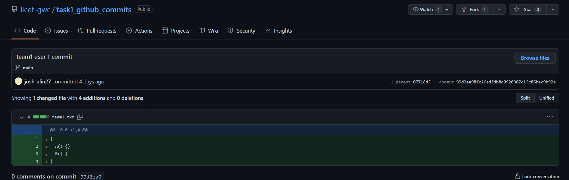

**User 2: Meghaa Rhenith R**

* Cloned the repo to local machine
* Updated “team1.txt” by adding 2 new functions in it -

{

A() {}

B() {}

C() {}

D() {}

}

* Pushed it to main branch of the repo by adding and committing

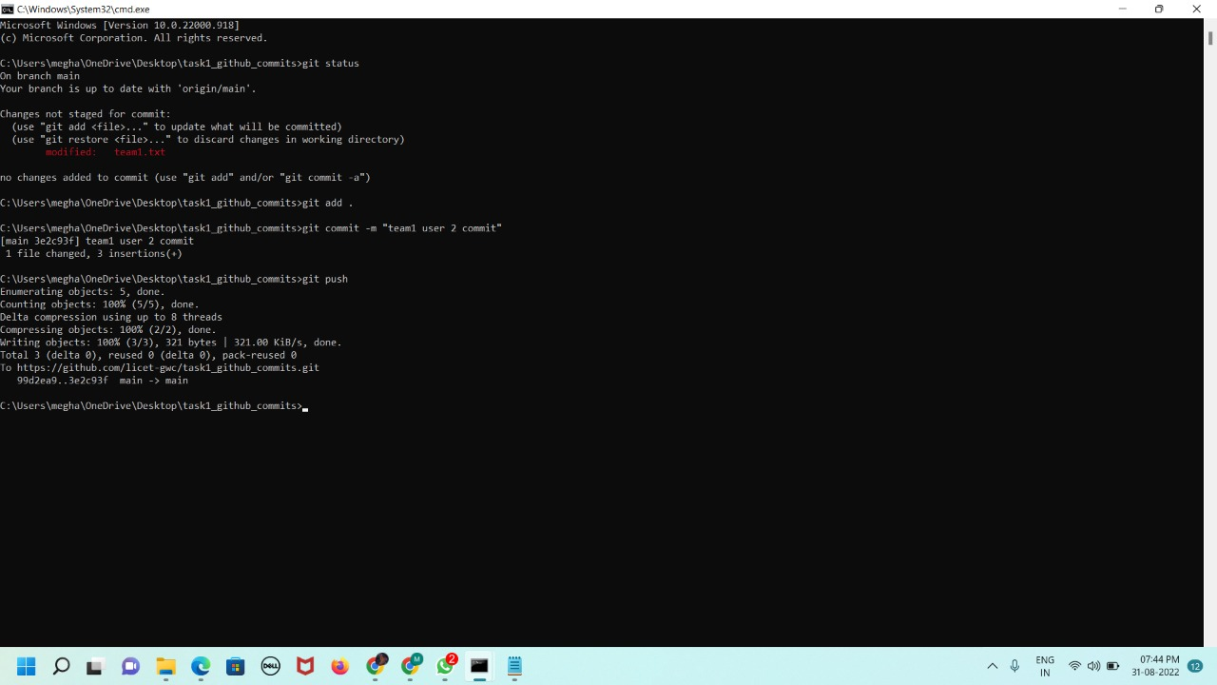

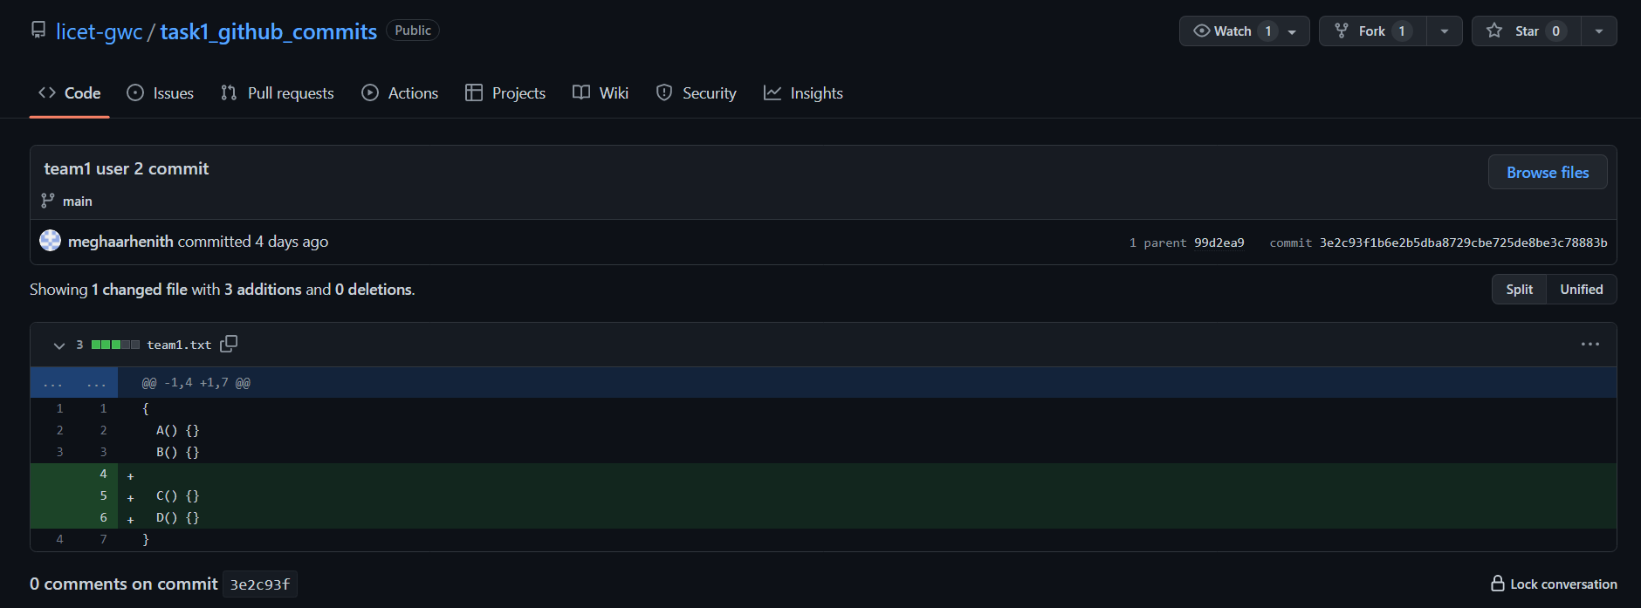

***User 3 and 4 cloned the repo at the same time.***

**User 3: Shekinah T**

* Updated “team1.txt” -

{

A() {}

B() {}

C() { A() }

D() {}

}

* Pushed it to main branch of the repo by adding and committing

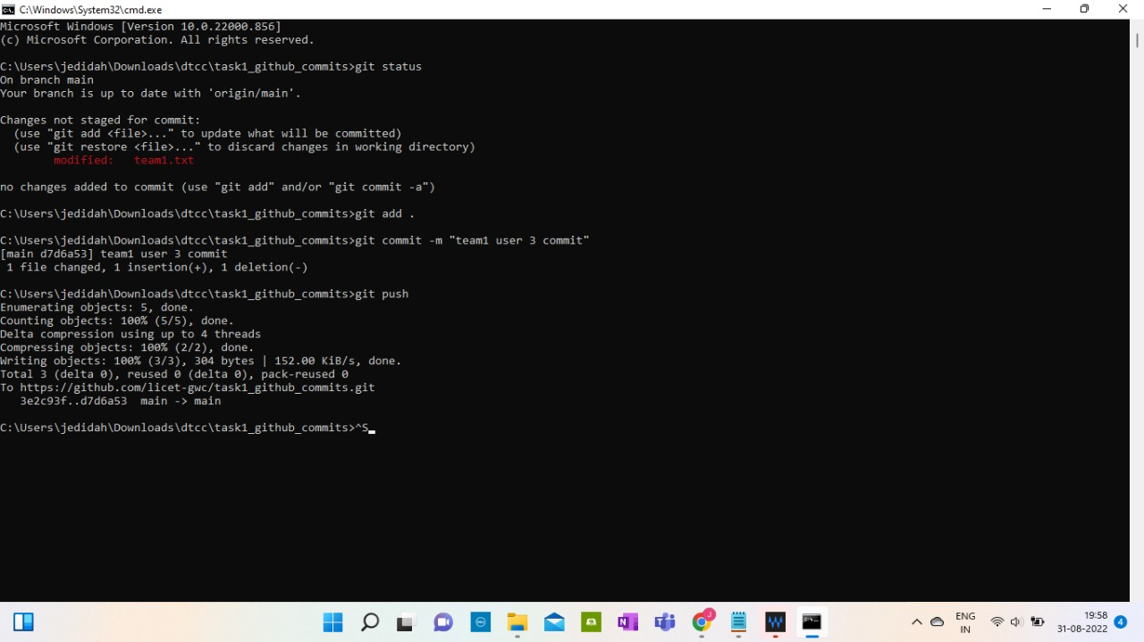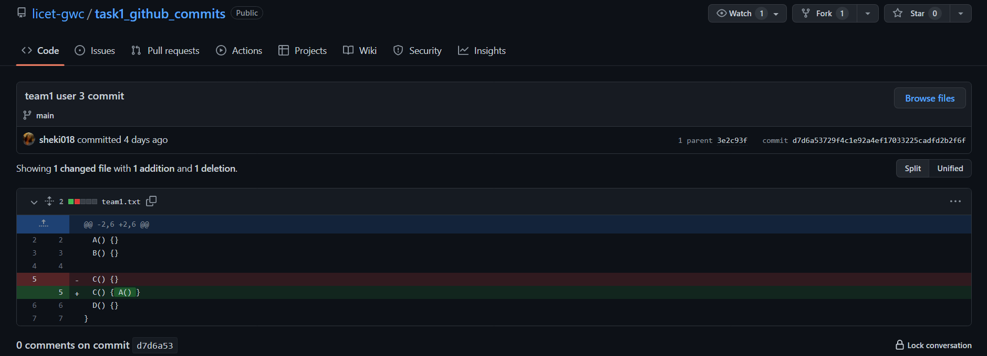

**User 4: Aishwarya P L**

* Updated “team1.txt” -

{

A() {}

B() {}

C() {}

D() { B() }

}

* Pushed it to main branch of the repo by adding and committing
* Received an error of conflict

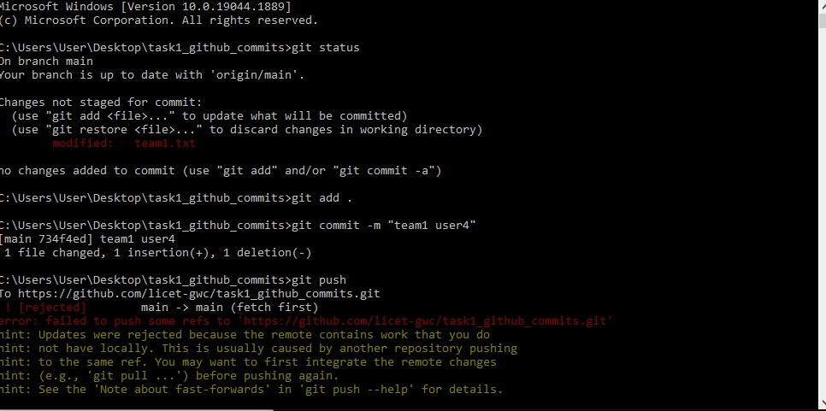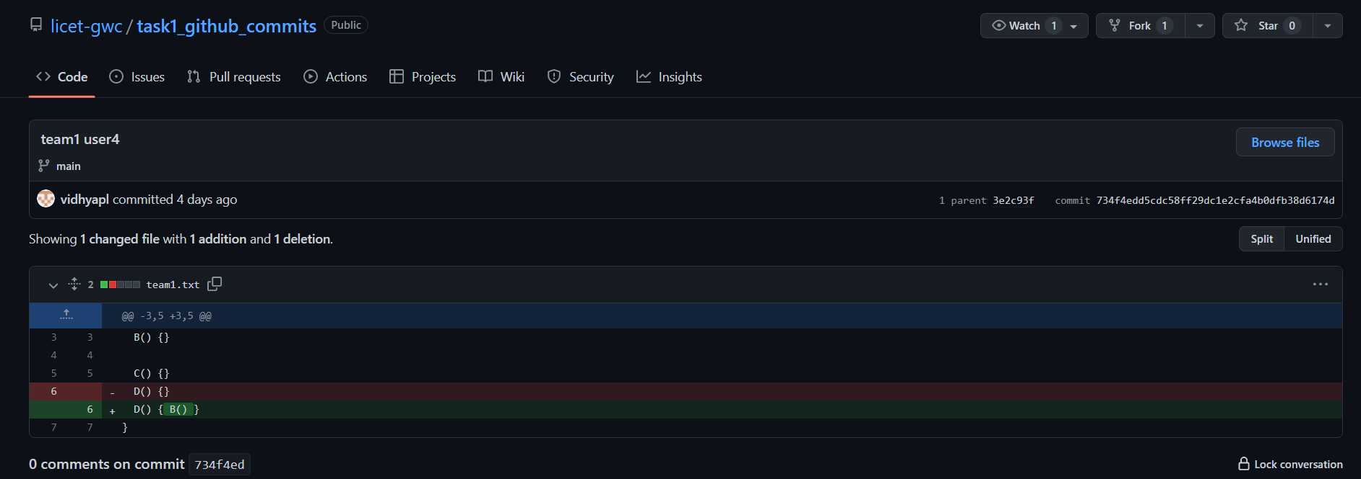

* Pulled changes made in the meantime
* Updated the text file to remove conflicts
* Pushed it to main branch of the repo by adding and committing again

